Investigating the mechanical and physical properties of lightweight geopolymer concrete
Mohammed Ali Abdulrehman ^{1,3}* , Akram Q. Moften ¹ , Ali S. Noori ¹ and Mohammed Qasim Mutair ² , Ahmed k. Al-kamal ^{1,4}.
¹ Materials Engineering Department, Faculty of Engineering, Mustansiriyah University, Baghdad, Iraq. ² National Center for Construction Laboratories, Baghdad, Iraq.
³School of Materials and Mineral Resources Engineering, Universiti Sains Malaysia, 14300 Nibong Tebal, Pulau Pinang, Malaysia.
⁴ University of Duisburg-Essen, Duisburg, Germany.

A R T I C L E I N F O  Article history:  Received 01 January 2024  Received in revised form 01 February 2024  Accepted 01 May 2024  Keywords:  Lightweight concrete  geopolymer  slag  thermostone  montmorillonite |  | A B S T R A C T  Using waste materials and by-products from various building sectors is becoming increasingly popular because natural resources are depleted quickly. Geopolymer concrete based on by-product material is a relatively new environmental material that does not need the presence of ordinary Portland cement as a binder. This study involved producing lightweight geopolymer concretes using a slag binder and replacing the conventional fine and coarse aggregates with two types of locally available lightweight aggregate (thermostone and montmorillonite). Several sequential steps were used to process the aggregates, with a series of tests conducted to evaluate the concrete properties in different states. The fresh state test included the slump test, while the hardened concrete tests involved compressive strength, flexural strength, density, thermal conductivity, and water absorption. This study indicated the suitability of lightweight concrete mixtures for various constructional applications. The most reliable mixture was the GMM, which consisted of coarse montmorillonite (5–25 mm) and fine montmorillonite aggregates. This mixture exhibited the highest compressive strength of 23.3 MPa, flexural strength of 3.25 MPa compare to other LWGC mixtures, and a low density of 1785 kg/m³. The GMM density was 23.97% lower than the reference mixture, whereas the thermal insulation significantly improved by 65.58%. Consequently, this improvement was evident in the thermal conductivity coefficient, which measured approximately 0.349 W/m.K. In addition, the GTT mixture containing thermostone aggregate (5-25 mm) yielded the most optimal thermal insulation and lowest density of 0.267 W/m.K and 1552 kg/m³, respectively. In general, the strength and density of the LWGC mixtures in this study meet the requirements of lightweight structural applications.  © 2024 University of Al-Qadisiyah. All rights reserved

- Introduction
A lower concrete density allows lighter and smaller structural members to enhance the available foundations of buildings and increase the seismic resistance in the upper section of buildings. Another advantage of using structural lightweight concrete (LWC) is reducing dead load weights. Lighter and smaller components of precast concrete parts can also lower the costs of lifting and transporting mechanisms [1]. Given that the current predominant global concern is environmental pollution, the building sector is creating alternative concrete binders to address the pollution caused by ordinary Portland cement (OPC)-based pollutants [2]. Geopolymer technology is currently being considered in which alumina and silica molecules in an active pozzolanic substance (slag) undergo a chemical reaction to produce geopolymer binders under highly alkaline conditions [3]. Hence, combining slag binder with lightweight aggregate (LWA) is expected to produce environmentally friendly concrete owing to its significant advantages. Slag binder positively mitigates CO2 emissions from concrete building structures, while LWA offers energy-saving advantages.
Numerous studies have investigated the properties of lightweight concrete, For example, Tayeh et al. studied sought to determine how high temperatures affected lightweight geopolymer concrete (LWGC) and lightweight ordinary concrete (LWOC), which were composed of natural pumice and lightweight expanded clay aggregate (LECA) with trapped air added. [4]. Meanwhile, a study by Sanjayan et al. examined the characteristics of lightweight geopolymer samples incorporating aluminium powder for aeration [5]. Generally, the application of aluminium powder for creating foam in traditional concrete is widely recognised. Another study by Jawad et al. investigated the geopolymer concrete bubbled slabs (exposed to fire flame under punching shear failure) reinforced with metakaolin as the base material [6]. The study initiated the geopolymerisation process using sodium silicate (Na₂SiO₃) and sodium hydroxide (NaOH) as alkali activation solutions. Moreover, the slabs were reinforced with a mesh of glass fibres and plastic balls as additives.
Several studies focused on recycled aggregate, including the research conducted by Gökçe and Şimşek. They specifically investigated the properties of recycled aggregate concrete, focusing on two aspects: water-cement ratio (WC) and recycled aggregate content (RAC). An investigation was conducted to analyze the characteristics of waste concrete, including the compressive strength of the concrete and its aggregate. The first part of the study, referred to as WCs, studies five specific water/concrete ratios (0.69, 0.54, 0.42, 0.37, 0.32) for each type of aggregate and three different strength categories of thermostone aggregates and concrete mixtures. The second stage of the investigation, known as RACs, utilized 100% coarse recycled aggregates from each water closet (WC) and three different water-to-cement ratios (0.30, 0.35, and 0.40). The hardened WC and RAC samples underwent several tests including compressive strength, water absorption, Schmidt rebound hammer, specific gravity, and ultrasonic pulse velocity[7].Togay Ozbakkaloglu et al. conducted a study on the mechanical and durability properties of concretes produced with recycled aggregate of different sizes and quantities. Fourteen sets of RACs were manufactured. Each batch underwent testing to ascertain its splitting tensile strength, flexural strength, elastic modulus, drying shrinkage, workability, and water absorption. The test criteria included the dimensions of the coarse aggregates, the proportion of recycled aggregate replacement, and the concrete preparation process[8]. In addition, S. Mesgari et al. conducted a study on the characteristics of Portland cement concrete and geopolymer concrete. They examined the effects of varying amounts of recycled coarse geopolymer aggregates (replacing coarse natural aggregates by 0%, 20%, 50%, and 100%) and compared them to Portland cement concrete that included recycled Portland cement concrete aggregates [9].
A study by Abbas et al. created geopolymer-reinforced concrete beams using three different fibre-reinforced polymer material types [10]. These beams were reinforced with a large web transverse aperture to investigate their flexural behavior. Goaiz et al. conducted a study on the tensile properties of geopolymer concrete made from recycled materials and reinforced with steel fiber. The steel fiber reinforced geopolymer concrete employed in this experiment mainly consisted of waste materials. The recycled steel fiber was derived from tires and subsequently transformed into small fibers with an average diameter of 0.7 mm and a length of 20 mm [11]. In addition, a further study conducted by Goaiz et al. examined the effect of including steel bars on the results of the core tests for recycled aggregate lightweight concrete (LWC). In order to achieve this objective, a solitary blend of lightweight concrete was created using 48 concrete cores. The mixture was constructed from a slab of 1 meter in width, 1.5 meters in length, and 0.15 meters in thickness. The core has a diameter of 90 mm and a height of 150 mm. Three different steel bar diameters (12, 16 mm, and 20 mm) were tested at six specific points (25, 45, and 65 mm) from the base of the core and (15 and 30 mm) from its center line [12].
Likewise, Abdulla et al. assessed the impact of silica fume on the resistance of LWC against acid, this study yielded significant findings regarding the influence of acid on lightweight concrete, with and without silica fume. Although the silica fume enhanced the acid resistance of concrete, this benefit was not consistently sustained and could even diminish when incorporating superplasticisers [13]. Another study conducted by Kamel et al. established a mathematical relationship between non-destructive tests and destructive tests for lightweight concrete consisting of slag as a binder and containing pumice aggregate and bentonite [14].
It has been noted in previous studies that some of them have discussed the properties of lightweight concrete consisting of cement as a binder, others have discussed the possibility of producing lightweight concrete based on recycled aggregate, others have discussed the properties of lightweight aggregate, and others have discussed the properties of geopolymer concrete, while thus, This study addressed the possibility of utilizing blast furnace slag in the production of lightweight geopolymer concrete and thus reducing environmental pollution caused by carbon dioxide emissions during cement manufacturing stages. The mixture was obtained by replacing traditional aggregates with lightweight aggregates (thermostone and montmorillonite), where the aggregate resulting from thermostone is recycled aggregate from thermostone waste, while the second aggregate is lightweight aggregate manufactured from raw materials available in Iraq, in addition to the fact that the first type is considered to be from a local source. In addition, many mechanical and physical properties of this type of environmentally friendly concrete were evaluated.
- Materials and Lab Equipment
  - Materials
2.1.1 Slag
The slag in this study was procured from the Swiss Sika Company. Subsequently, the slag composition test was performed at the Iraqi National Centre for Construction Laboratories to ascertain its chemical composition. Table 1 tabulates the chemical composition findings of the slag.
Table 1. Chemical composition summary of the slag
Content (%) | Oxide
29.95 | SiO₂
17.15 | Al₂O₃
40.63 | CaO
01.42 | Fe₂O₃
08.90 | MgO
01.58 | SO₃
00.37 | LSF
    - NaOH
The NaOH solid flakes from the Iranian Chloran Chemical Production Company were dissolved in distilled water to obtain the desired molarity of the geopolymer concrete solution.

    - Na₂SiO₃
This study applied Na₂SiO₃ from the United Arab Emirates (UAE). The percentages of Na2O: SiO₂:H₂O influenced the concentration of the Na₂SiO₃ solution.
    - Coarse aggregate
This study utilised five different coarse aggregate types: natural crushed gravel (5–25) mm, thermostone coarse aggregate (5–25) mm, thermostone coarse aggregate (10–40) mm, montmorillonite coarse aggregate (5–25) mm, and montmorillonite coarse aggregate (grading 10–40) mm. Table 2 presents that the assessment outcomes conformed to the standard specification for concrete aggregates American Society for Testing and Materials (ASTM C33) [15]. The thermostone was acquired from construction waste material and crushed by the aggregate crusher (see Fig. 1). These crushed stones were then sieved until the desired gradations were achieved.

Table 2. Summary properties of fabricated coarse aggregate
Thermostone | Montmorillonite | Crushed Gravel | Property
0.252 | 0.97 | 2.6 | Specific gravity
0.41 | 0.77 | 0.09 | Sulphate content (%)
7.9 | 8.0 | 0.63 | Absorption (%)
29.4 | 26.8 | 15.1 | Impact value (%)
30.6 | 28.1 | 16.8 | Crushing value (%)

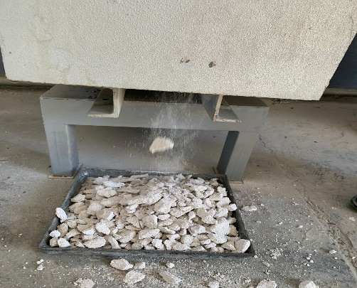
Figure 1. The thermostone coarse aggregate
The montmorillonite was acquired from Iraq/Anbar City in collaboration with the Geological Survey Establishment and the Mining Department. Four fundamental steps are involved in the manufacturing process of montmorillonite LWA as follows [16]:
- First, the raw ingredients were prepared.
- Second, the Na₂SiO₃ liquid was mixed with montmorillonite clay in a ratio of 1:1.25 by weight. Subsequently, the clay-like slurry was shaped into spherical balls, which were air-dried for 24 h at room temperature. This process was followed by an additional 24 h of drying at 100°C to ensure complete dehydration.
- Third, the temperature of the mixture was raised by subjecting the rounded clay balls to a firing temperature of 800°C in an electrically heated furnace for 2 h.
- Fourth, the fired balls were manually crushed using a crusher and screened on a typical sieve series to achieve the desired size for coarse LWA grading (see Fig. 2).

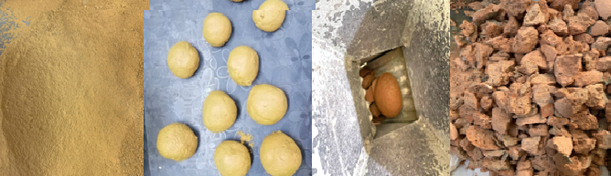
Figure 2. The preparation steps of the montmorillonite coarse aggregate
    - Fine aggregate
This study used three distinct aggregate types: natural sand, thermostone fine aggregate, and montmorillonite fine aggregate. Table 3 reveals that the evaluation outcomes conformed to the standard specification for concrete aggregates (ASTM C33). Meanwhile, Table 4 provides the chemical analysis for the fabricated thermostone and montmorillonite aggregates.

Table 3. Summary properties of the fine aggregate
Thermostone | Montmorillonite | Natural Sand | Characteristic
7.33 | 8.61 | 0.78 | Absorption (%)
1.31 | 1.65 | 2.63 | Specific gravity
0.41 | 0.77 | 0.039 | Sulphate content (%)
Table 4. Chemical analysis summary of the montmorillonite and thermostone aggregates
Thermostone Result% | Montmorillonite Result% | Material %
48.03 | 62.69 | SiO₂
3.23 | 13.77 | AL₂O₃
3.09 | 11.50 | Fe₂O₃
38.88 | 7.09 | CaO
2.26 | 3.98 | MgO
0.41 | 0.77 | SO₃
4.10 | 0.2 | LSF
2.1.6 High range water reducing admixture (HRWRA)
The HRWRA was supplied by a local vendor and adhered to the ASTM C494 requirements for types A and F (depending on the dosage applied). Table 5 displays the basic properties of Sikament N Plus [17].
Table 5. Summary of the plasticiser characteristics
Description | Technical property
7–11 | pH value
Naphthalene formaldehyde sulfonate | Basis
Dark brownish liquid | Colour
1.181 ± 0.010 @ 20°C | Density(kg/l)

    - Additional water
The geopolymer concrete was supplemented with appropriate regular tap water for the concrete mix design.
3. LWGC Mixes
The mix design was derived from empirical knowledge of specific materials [18]. Tables 6a and 6b summaries the LWGC designs.

Table 6a. Summary of the mix designs for various LWGCs
NaOH  Molarity | NaOH: Na₂SiO₃ | HRWRA  (kg/m³) | Added  water (kg/m³) | Fine aggregate  (kg/m³) | Coarse aggregate  (kg/m³) | Alkaline  liquids (kg/m³) | Slag  (kg/m³) | Mix*
10 | 1:2.5 | 8 | 100 | 576 | 1124 | 180 | 400 | RM
10 | 1:2.5 | 8 | 100 | 287 | 108.5 | 180 | 400 | GTT
10 | 1:2.5 | 8 | 100 | 362.2 | 108.5 | 180 | 400 | GTM
10 | 1:2.5 | 8 | 100 | 576 | 108.5 | 180 | 400 | GTS
10 | 1:2.5 | 8 | 100 | 362.2 | 419.4 | 180 | 400 | GMM
10 | 1:2.5 | 8 | 100 | 287 | 419.4 | 180 | 400 | GMT
10 | 1:2.5 | 8 | 100 | 576 | 419.4 | 180 | 400 | GMS
10 | 1:2.5 | 8 | 100 | 287 | 108.5 | 180 | 400 | MTT
10 | 1:2.5 | 8 | 100 | 362.2 | 108.5 | 180 | 400 | MTM
10 | 1:2.5 | 8 | 100 | 576 | 108.5 | 180 | 400 | MTS
10 | 1:2.5 | 8 | 100 | 362.2 | 419.4 | 180 | 400 | MMM
10 | 1:2.5 | 8 | 100 | 287 | 419.4 | 180 | 400 | MMT
10 | 1:2.5 | 8 | 100 | 576 | 419.4 | 180 | 400 | MMS
* RM = a reference geopolymer mix with normal fine and coarse aggregate, GXX = a geopolymer mixture with (5–25) mm grain size of coarse aggregate, MXX = a geopolymer mixture with (10–40) mm grain size of coarse aggregate, C = coarse aggregate, F= fine aggregate, T = crushed thermostone, and M = montmorillonite

Table 6b. Summary of the coarse and fine aggregates for all mix designs
Grade | Fine Aggregate | Coarse Aggregate | Mix
5–25 | Sand | Gravel | RM
5–25 | Thermostone | Thermostone | GTT
5–25 | Montmorillonite | Thermostone | GTM
5–25 | Sand | Thermostone | GTS
5–25 | Montmorillonite | Montmorillonite | GMM
5–25 | Thermostone | Montmorillonite | GMT
5–25 | Sand | Montmorillonite | GMS
10–40 | Thermostone | Thermostone | MTT
10–40 | Montmorillonite | Thermostone | MTM
10–40 | Sand | Thermostone | MTS
10–40 | Montmorillonite | Montmorillonite | MMM
10–40 | Thermostone | Montmorillonite | MMT
10–40 | Sand | Montmorillonite | MMS

4. Preparation of Alkaline Solutions for the Geopolymer Mixtures
  - Preparation of NaOH solution
To prepare a 10 Molar (M) NaOH solution, 314 g of NaOH solid flakes were added to 686 g of water for producing 1 Kg of solution.
  - Preparation of alkaline liquids for mixtures of lightweight geopolymer concrete
The NaOH solution was combined with the Na₂SiO₃ solution at a ratio of 1:2.5 to prepare the alkaline liquid. Particularly, the NaOH solution was designed one day before mixing it with the other mixture components [19].
- LWGC Mixing Procedure
The dry components (slag, fine aggregate, and coarse aggregate) were mixed for 2 to 3 minutes using a 230 L mixer. Subsequently, additional water, plasticiser, and pre-prepared alkaline liquid were introduced into the mixture. This mixture was combined for another 4 to 5 mins to achieve an optimal homogeneity [19].
- Curing
The curing process was conducted in open air for 27 days after removing the mould samples. The temperature during this period ranged between 25 to 30°C.
- LWGC Tests
  - Slump test
The slump test was performed on various LWGCs as a standard method to demonstrate its workability. This test was conducted promptly after combining the mixture using the procedure outlined in ASTM C-143 [20].
  - Density test
The sample density values of the LWGCs were determined using the ASTM C642 [21]. This process was performed using a precision electronic balance with an accuracy of 1 g. The cube samples (100 ×100 ×100) mm were then dried. Finally, the weight was measured and divided by the volume of the cube.
  - Thermal conductivity test
The dimensions of the LWGCs used were (100×100×100)mm. Fig. 3 depicts the heat conductivity measurements using the ASTM-C1363 [22]. A Fourier equation was applied to determine the thermal conductivity coefficient value.
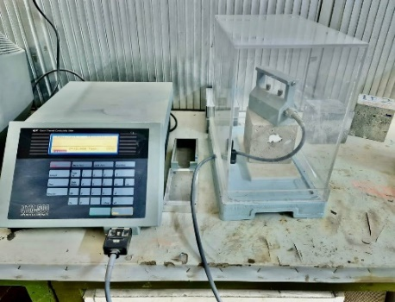
Figure 3. The thermal conductivity test
  - Compressive strength (Cs)
This test followed the specified standard BS-EN-12390-3 [23]. Each cube measured (100×100 ×100) mm for the LWGCs. The test involved a hydraulic press with a capacity of 3500 kN (see Fig. 4). This test was conducted once the samples had completed the curing process and achieved a 28-day age.
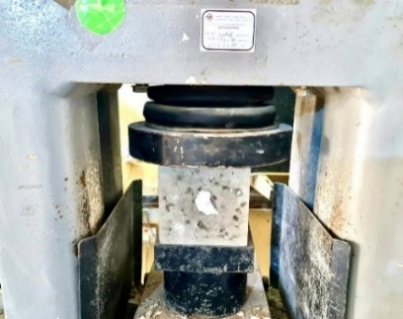
Figure 4. The compressive strength test
  - Flexural strength (fr)
The dimensions of the LWGCs were (130×130×530) mm. These samples were subjected to a pressure test utilising a two-point load applied by a machine with a 300 KN capacity (see Fig. 5). Additionally, this test followed the specifications outlined in ASTM-C78 [24].
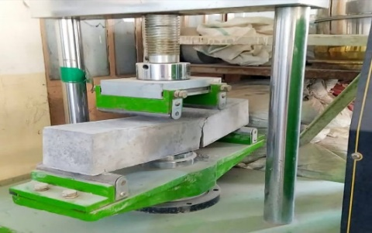
Figure 5. The flexural strength test
  - Water absorption test
The water absorption of a cube with dimensions of (100 × 100 × 100) mm was quantified as a percentage using the guidelines outlined in ASTM-C642 [25]. The dry weight was determined by subjecting the sample to an oven from 100 to 110°C. Meanwhile, the wet weight was calcluated by immersing the sample in water at 21°C for 24 h. lastly, the water absorption percentage was computed.
- Results and Discussion
This section assessed and analyses the outcomes derived from the tests above.
8.1 Slump Test
Table 7 presents the measured slump test values for various LWGCs. An overall reduction in slump values was detected for all mixtures compared to the reference mixture. The following factors contribute to a discrepancy in the decreased values:
- The montmorillonite aggregate's higher capability to absorb water than that of conventional and thermostone aggregates resulted in a reduced workability. For example, the slump value of the GMM mixture exhibited a reduction of 32.96% compared to the RM mixture and a decrease of 28.57% compared to the GTT mixture, and the regression value of MMM blend showed a decrease of 30.76% compared to RM blend and a decrease of 20% compared to MTT blend. As for the other of the mixtures, the fluctuation varies depending on the quantity and type of aggregate, whether the aggregate is montmorillonite or thermostone.
- When utilising gradient aggregates (10-40) mm, the slump value was higher compared to using gradient aggregates (5-25) mm for the same mixture. This resulted from the slump value being increased by the larger maximum aggregate size [26]. For example, the slump value of the MMM combination was 2.85% higher than that of GMM mixture, and the slump value of the MTT mixture was 2% greater than that of the GTT mixture.
Table 7. Summary of the slump test results
Slump (mm) | Mix
208 | RM
196 | GTT
151 | GTM
182 | GTS
140 | GMM
178 | GMT
161 | GMS
200 | MTT
157 | MTM
190 | MTS
144 | MMM
180 | MMT
166 | MMS
  - Density Test
Table 8 tabulates the density test findings for various LWGCs. The density values of all mixtures were lower when compared to the density value of the reference mixture. This loss can be attributable to several factors, such as following factors:
- The aggregates composed of montmorillonite exhibited a higher density compared to the aggregates composed of thermostone. More precisely, the density of the concrete that included thermostone aggregate GTT (both fine and coarse) was 13% less than the density of the concrete that included montmorillonite aggregate GMM (both fine and coarse), The density of the concrete containing thermostone aggregate MTT (both fine and coarse) was 14.8% lower than the density of the concrete containing montmorillonite aggregate MMM (both fine and coarse). The density of the concrete containing thermostone aggregate MTT (both fine and coarse) was 14.8% lower than the density of the concrete containing montmorillonite aggregate MMM (both fine and coarse).
- The density values of the traditional fine and coarse aggregates were greater than the fine and coarse thermostone aggregates. Notably, the density value of concrete containing thermostone aggregate GTT (fine and coarse) decreased by 33.9% compared to concrete containing standard aggregate RM (fine and coarse), and the density of concrete with montmorillonite aggregate GMM (both fine and coarse) decreased by 23.9% in comparison to concrete with traditional aggregate RM (both fine and coarse).
- The graded aggregates (10-40) mm resulted in a marginally greater density compared to graded aggregates (5-25) mm for the same mixtures. This finding was due to the employment of graded aggregates (10-40) mm permitting larger amounts of fine aggregates to penetrate, yielding a higher density. Regardless of the aggregate type, the fine aggregate possessed a greater density than the coarse aggregate. Particularly, a reduction of 0.6% in the density of concrete was observed while using montmorillonite aggregate GMM (fine and coarse) (5-25) mm compared to the montmorillonite aggregate MMM (fine and coarse) (10-40) mm.

Table 8. Summary of the density test results
Density (kg/m³) | Mix
2348 | RM
1552 | GTT
1587 | GTM
1626 | GTS
1785 | GMM
1761 | GMT
1834 | GMS
1530 | MTT
1598 | MTM
1627 | MTS
1796 | MMM
1764 | MMT
1847 | MMS

  - Thermal Conductivity Test
All mixtures exhibited a lower thermal conductivity than the reference mixture. Variations were also detected among different LWGC mixture types. Table 9 lists the thermal conductivity test results. Similar to the interpretations provided for the density test, a clear correlation between density and thermal conductivity was observed. An elevation in density corresponded to an increase in conductivity, while a reduction in density corresponded to a fall in conductivity. Consequently, the GTT mixture highlighted the most effective thermal insulation, achieving the lowest thermal conductivity value of 0.267 W/m K. This outcome represented a significant decrease of 73.6% compared to the thermal conductivity value of the reference mixture.
Table 9. Summary of the thermal conductivity test results
Thermal conductivity (W/m K) | Mix
1.014 | RM
0.267 | GTT
0.281 | GTM
0.302 | GTS
0.349 | GMM
0.335 | GMT
0.370 | GMS
0.277 | MTT
0.295 | MTM
0.302 | MTS
0.358 | MMM
0.338 | MMT
0.383 | MMS
  - Compressive Strength Test
The Compressive strength test results on the LWGC samples were investigated. Table 10 reveals that all the compressive strength values are lower than the reference mixture. A discrepancy in the decrease level between different mixtures was also presented. Therefore, this discrepancy is caused by the following factors:
- The montmorillonite aggregate (fine and coarse) exhibited superior properties to the thermostone aggregate. This finding was attributed to the montmorillonite aggregate interaction with the Na₂SiO₃ solution before mixing. Previous studies also focused on utilising montmorillonite as a binder after it has undergone combustion and been added to the Na₂SiO₃ solution [27]. Therefore, the compressive strength of the GMM mixture exceeded the GTT mixture by 35%, and the compressive strength of the MMM mixture surpassed that of the MTT mixture by 46%.
- The gradient aggregates (5-25) mm demonstrated higher mechanical qualities than gradient aggregates (10-40) mm. This result was due to the Na₂SiO₃ solution interacting with a larger aggregate surface area when a lower gradient was used. For example, the GMM mixture computed a 6.3% higher compressive strength than the MMM mixture, and the GTT mixture exhibited a 4.2% greater compressive strength compared to the MTT mixture. Fig. 6 portrays an interaction between the montmorillonite aggregate and the binder particles using an imaging tool (SEM) for GMM mixture.
- Table 4 presents that the fine montmorillonite aggregate produced superior outcomes compared to conventional sand. This outcome was attributed to the pozzolanic composition of montmorillonite aggregate. The aggregate also contained low volumes after being ground and crushed, which functioned similarly to binders when interacting with a Na₂SiO₃ solution. Thus, the GMM mixture exhibited a 9.9% higher compressive strength than the GMS mixture, whereas the MMM mixture generated a 6.3% higher compressive strength than the MMS mixture.
Table 10. Summary of the compressive strength test results
Compressive strength (MPa) | Mix
27.8 | RM
17.2 | GTT
19.5 | GTM
16.9 | GTS
23.3 | GMM
21.1 | GMT
21.2 | GMS
16.2 | MTT
19.3 | MTM
15.9 | MTS
21.9 | MMM
20.7 | MMT
20.6 | MMS

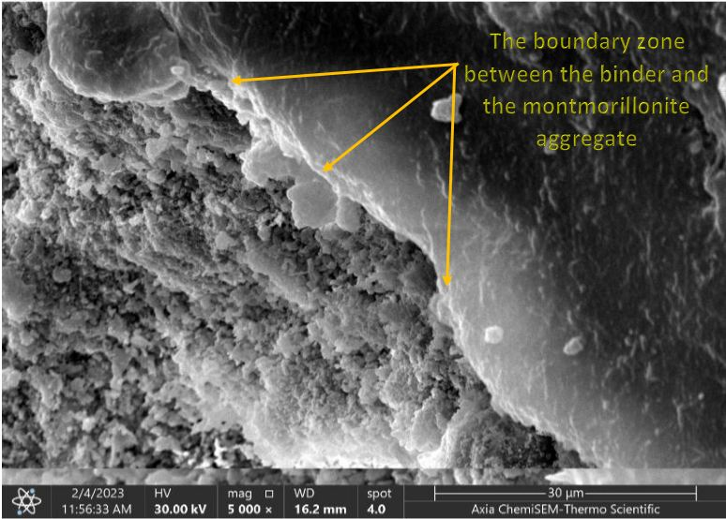
Figure 6. An image indicating the bonding area between the slag and montmorillonite aggregate.
  - Flexural Strength Test
Table 11 summarises the flexural strength test results. A lower flexural strength test value was noted than the reference mixture, with differences in the decline detected between LWGC mixtures. Thus, the same rationale described in the compressive strength test was applied to this test. The GMM mixture demonstrated the highest flexural strength value at 3.25 MPa, rendering it the most advantageous option for lightweight mixtures.
Table 11. Summary of the flexural strength results
Flexural  Strength (MPa) | Mix
3.96 | RM
2.20 | GTT
2.52 | GTM
2.16 | GTS
3.25 | GMM
2.79 | GMT
2.82 | GMS
2.11 | MTT
2.46 | MTM
2.07 | MTS
3.08 | MMM
2.73 | MMT
2.71 | MMS

  - water Absorption Test
Table 12 displays the water absorption test results. Each mixture presented a higher water absorption value than the reference mixture. A discrepancy in the increase is also observed due to several factors as follows:
- The montmorillonite aggregate enhanced the absorption capacity compared to other aggregate types due of its composition of clay materialsials. For example, the GMM mixture presented a water absorption capacity 201% higher than the RM mixture and 64.2% higher than the GTT mixture, and the MMM mixture exhibited a water absorption capacity that was 178% greater than the RM mixture and 53.2% greater than the MTT mixture.
- The presence of coarse thermostone aggregate in concrete causes higher porosity, resulting in enhanced absorbency compared to the traditional coarse aggregate. For example, the GTS mixture exhibited a water absorption capacity that was 89.7% higher than that of the RM mixture, and the MTS mixture demonstrated a water absorption capacity that was 88.8% greater than that of the RM mixture.
Table 12. Summary of the water absorption test results
Absorption (%) | Mix
3.22 | RM
5.90 | GTT
6.28 | GTM
6.11 | GTS
9.69 | GMM
6.95 | GMT
7.01 | GMS
5.84 | MTT
6.21 | MTM
6.08 | MTS
8.95 | MMM
6.65 | MMT
6.72 | MMS
Conclusion
This study successfully demonstrated the environmental friendliness of all the LWGCs based on the outcomes of various mechanical and physical tests. The study provides an experimental work to produce the LWGC based on local coarse and fine aggregates, where, the most prominent conclusions
- The slag in all the mixtures functioned as an alternative binder for cement, resulting in reduced cement production-related CO₂ emissions. The above mixtures could be suitable for numerous applications (such as non-load-bearing walls or upper floors) due to their light-weight, good thermal insulation and relatively acceptable compressive strength. Nonetheless, these aspects may not be suitable for all structural applications.
- Among all mixtures, the GMM mixture containing coarse and fine montmorillonite aggregates of grade (5-25 mm) was recommended when selecting an optimal mixture. The GMM exhibited good mechanical properties, such as compressive and bending strengths. It was found that the GMM obtained the highest compressive strength and flexural strength of 23.3 MPa and 3.25 MPa, respectively compared to other LWGC mixtures.
- The GTT mixture containing coarse and fine crushed thermostone aggregate of grade (5-25 mm) yielded the most optimal thermal insulation and lowest density of 0.267 W/m.K and 1552 kg/m³, respectively.
- The GTT mixture in this study also yielded a compressive strength of 17.2 MPa which can be employed in simple structural applications.
- One downside of the GMM mixture was its high water absorption rate, which may affects the long-term durability of this type of LWGC due to the high permeability of aggressive liquids. This drawback indicated that the GMM mixture should incorporate a waterproof coating in water-exposed applications.
Funding Source
The authors declare that no funds, grants, or other support were received during the preparation of this manuscript.
Competing Interests
The authors have no relevant financial or non-financial interests to disclose.
Conflict of Interest
The authors declare that there are no conflicts of interest regarding the pubication of this manuscript.
Author Contributions
All authors contributed to the study conception and design. Material preparation, data collection and analysis were performed by Mohammed Ali Abdulrehman, Akram Q. Moften, Ali Sabah Noori, and and Mohammed Qaseem Mutair. The first draft of the manuscript was written by Mohammed Ali Abdulrehman and all authors commented on previous versions of the manuscript. All authors read and approved the final manuscript.
Acknowledgement
The authors would like to thank the laboratory staff at Mustansiriyah University (Iraq/Baghdad) for conducting the experiments for this study.
References
1. Kayali, O., Fly ash lightweight aggregates in high performance concrete. Construction and Building Materials, 2008. 22(12): p. 2393-2399.
2. Shinde, B., B. Suryawanshi, and D. Chougule, A Characteristic Study of Light Weight Geopolymer Concrete. International Research Journal of Engineering and Technology (IRJET), 2016. 3(2): p. 1555-1558.
3. Diaz-Loya, E.I., E.N. Allouche, and S. Vaidya, Mechanical properties of fly-ash-based geopolymer concrete. ACI materials journal, 2011. 108(3): p. 300-306.
4. Tayeh, B.A., et al., Effect of elevated temperatures on mechanical properties of lightweight geopolymer concrete. Case Studies in Construction Materials, 2021. 15(1): p. e00673.
5. Sanjayan, J.G., et al., Physical and mechanical properties of lightweight aerated geopolymer. Construction and Building Materials, 2015. 79(1): p. 236-244.
6. Jawad, H.K. and W.A. Waryosh, Behavior of Glass Fiber Geoploymer Bubble Slabs Exposed to Fire Flame. Journal of Engineering and Sustainable Development (JEASD), 2021. 25(Special Issue 2021): p. 127-134.
7. Gökçe, H.S. and O. Şimşek, The effects of waste concrete properties on recycled aggregate concrete properties. Magazine of Concrete Research, 2013. 65(14): p. 844-854.
8. Ozbakkaloglu, T., A. Gholampour, and T. Xie, Mechanical and durability properties of recycled aggregate concrete: effect of recycled aggregate properties and content. Journal of Materials in Civil Engineering, 2018. 30(2): p. 04017275.
9. Mesgari, S., A. Akbarnezhad, and J. Xiao, Recycled geopolymer aggregates as coarse aggregates for Portland cement concrete and geopolymer concrete: Effects on mechanical properties. Construction and Building Materials, 2020. 236: p. 117571.
10. Abbas, O.H. and H. A.Numan, Enhancing of Flexural Strength of Web Opening Reinforced Geopolymer Beams by Using FRP Strips. Journal of Engineering and Sustainable Development (JEASD), 2021. 25(Special Issue 2021): p. 135-149.
11. Goaiz, H., et al., Evaluation of steel fiber reinforced geopolymer concrete made of recycled materials. International Journal of Engineering, 2022. 35(10): p. 2018-2026.
12. Goaiz, H.A., et al., Evaluation of lightweight concrete core test including steel bars. International Journal of Engineering, 2023. 36(6): p. 1121-1128.
13. Abdulla, A.I., Acidic Attack Resistance of Lightweight Concrete with SF. Journal of Engineering and Sustainable Development (JEASD), 2013. 17(2): p. 1-21.
14. Kamel, M.H., Y.K. Ibrahim, and M.A. Abdulrehman. Relation between destructive and non-destructive tests of lightweight geopolymer concrete. in AIP Conference Proceedings. 2023. AIP Publishing.
15. ASTM-C33, Standard specification for concrete aggregates. Annual Book of American Society for Testing and Material Standards, 2017.
16. Abbas, W., W. Khalil, and I. Nasser, Production of lightweight Geopolymer concrete using artificial local lightweight aggregate. MATEC Web Conf., 2018. 162(MATEC Web Conf.): p. 02024.
17. ASTM-C494, Standard Specification for Chemical Admixtures for Concrete. Annual Book of American Society for Testing and Material Standards, 2004.
18. Hardjito, D. and B.V. Rangan, Development and Properties of Low-Calcium Fly Ash-Based Geopolymer Concrete. Research Report GC 1 Faculty of Engineering Curtin University of Technology Perth, Australia, 2005: p. 1-103.
19. Lloyd, N. and V. Rangan. Geopolymer concrete with fly ash. in Proceedings of the Second International Conference on sustainable construction Materials and Technologies. 2010. Ancona, Italy: UWM Center for By-Products Utilization.
20. ASTM-C143/C143M, Standard Test Method for Slump of Hydraulic-Cement Concrete. - 10a American National Standard. Annual Book of American Society for Testing and Material Standards, 2010.
21. BS-EN_12390-7, Testing hardened concrete. Density of hardened concrete. British Standards Institution, 2019.
22. ASTM-C1363, Standard Test Method for Thermal Performance of Building Materials and Envelope Assemblies by Means of a Hot Box Apparatus. Annual Book of American Society for Testing and Material Standards, 2019.
23. BS-EN-12390-3, Testing Hardened Concrete. Compressive Strength of Test Specimens, British Standards Institution. British Standards Institution, 2019.
24. ASTM-C78, Standard Test Method for Flexural Strength of Concrete. Annual Book of American Society for Testing and Material Standards, 2005.
25. ASTM-C642, Standard Test Method for Density, Absorption, and Voids in Hardened Concrete. Annual Book of American Society for Testing and Material Standards, 2022.
26. Neville, A.M., Properties of concrete. 5th ed. 2012, New York: Prentice Hall. 846
27. Kadar, J.M.A. and G. Dhanalakshmi, Experimental investigation on concrete by partial replacement on cement by bentonite and coarse aggregate by steel slag. International Journal of Innovative Research in Science, Engineering and Technology (IJIRSET), 2016. 5(6): p. 10302-10309.

